P, NP, and NP-Complete Problems

Polynomial time problems:

An algorithm solves a problem in polynomial time if its worst-case time efficiency belongs to O(p(n)) where p(n) is a polynomial of the problem’s input size n.

If the running time is some polynomial function of the size of the input n, for instance if the algorithm runs in linear time or quadratic time or cubic time, then we say the algorithm runs in polynomial time.

(An algorithm is said to be solvable in polynomial time if the number of steps required to complete the algorithm for a given input is for some nonnegative integer , where is the complexity of the input.)

Example: Computing the greatest common divisor of two integers, sorting a list, searching for a key in a list or for a pattern in a text string, checking connectivity and acyclicity of a graph, and finding a minimum spanning tree and shortest paths in a weighted graph.

Tractable Problems: Problems that can be solved in polynomial time are called tractable.

Intractable Problems:Problems that cannot be solved in polynomial time are called intractable.

Decision problem: a decision problem is a problem that can be posed as a yes or no answer of the input values. An example of a decision problem is deciding whether a given natural number is prime.

Many important problems that are not decision problems in their most natural formulation can be reduced to a series of decision problems.

For example, (graph coloring problem) instead of asking about the minimum number of colors needed to color the vertices of a graph so that no two adjacent vertices are colored the same color.
Decision problem: whether there exists such a coloring of the graph’s vertices with no more than m colors for m = 1, 2, . . . . (The latter is called the m-coloring problem.)
The first value of m in this series for which the decision problem of m-coloring has a solution solves the optimization version of the graph-coloring problem as well.

A deterministic algorithm:

In deterministic algorithm, for a given particular input, the computer will always produce the same output going through the same states.

for i from 1 to 9
print i
Output: 1 2 3 4 5 6 7 8 9

A nondeterministic algorithm:

non-deterministic algorithm, for the same input, the compiler may produce different output in different runs. (eg., generate random numbers that cannot be easily outguessed.)

It is a two-stage procedure that takes as its input an instance I of a decision problem and does the following.
Nondeterministic (“guessing”) stage: An arbitrary string S is generated that can be thought of as a candidate solution to the given instance I.
Deterministic (“verification”) stage: A deterministic algorithm takes both I and S as its input and outputs yes if S represents a solution to instance I. If S is not a solution to instance I, the algorithm either returns no or is allowed not to halt at all.
Nondeterministic algorithm is said to be nondeterministic polynomial if the time efficiency of its verification stage is polynomial.

Hamiltonian circuit problem Determine whether a given graph has a Hamiltonian circuit—a path that starts and ends at the same vertex and passes through all the other vertices exactly once.

Common feature of a vast majority of decision problems is the fact that although solving such problems can be computationally difficult, checking whether a proposed solution actually solves the problem is computationally easy, i.e., it can be done in polynomial time.

For example, it is easy to check whether a proposed list of vertices is a Hamiltonian circuit for a given graph with n vertices. All we need to check is that the list contains n + 1 vertices of the graph in question, that the first n vertices are distinct whereas the last one is the same as the first, and that every consecutive pair of the list’s vertices is connected by an edge.

Class P:

Class P is a class of decision problems that can be solved in polynomial time by (deterministic) algorithms. This class of problems is called polynomial.

Decidable problems: Decision problems that can be solved by an algorithm.

Undecidable problems: Decision problems that cannot be solved at all by any algorithm.

Class NP:
Class NP is the class of decision problems that can be solved by nondeterministic polynomial algorithms. This class of problems is called nondeterministic polynomial.
P є NP.

A decision problem D1 is said to be polynomially reducible to a decision problem D2, if there exists a function t that transforms instances of D1 to instances of D2 such that:
1. t maps all yes instances of D1 to yes instances of D2 and all no instances of D1 to no instances of D2
2. t is computable by a polynomial time algorithm

A decision problem D is said to be NP-complete if:
1. it belongs to class NP
2. every problem in NP is polynomially reducible to D

Closely related decision problems are polynomially reducible to each other.
For example, let us prove that the Hamiltonian circuit problem is polynomially reducible to the decision version of the travelling salesman problem.
travelling salesman problem can be stated as the existence problem of a Hamiltonian circuit not longer than a given positive integer m in a given complete graph with positive integer weights.

We can map a graph G of a given instance of the Hamiltonian circuit problem to a complete weighted graph G representing an instance of the traveling salesman problem by assigning 1 as the weight to each edge in G and adding an edge of weight 2 between any pair of nonadjacent vertices in G.

Obviously, this transformation can be done in polynomial time.

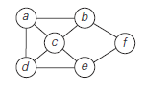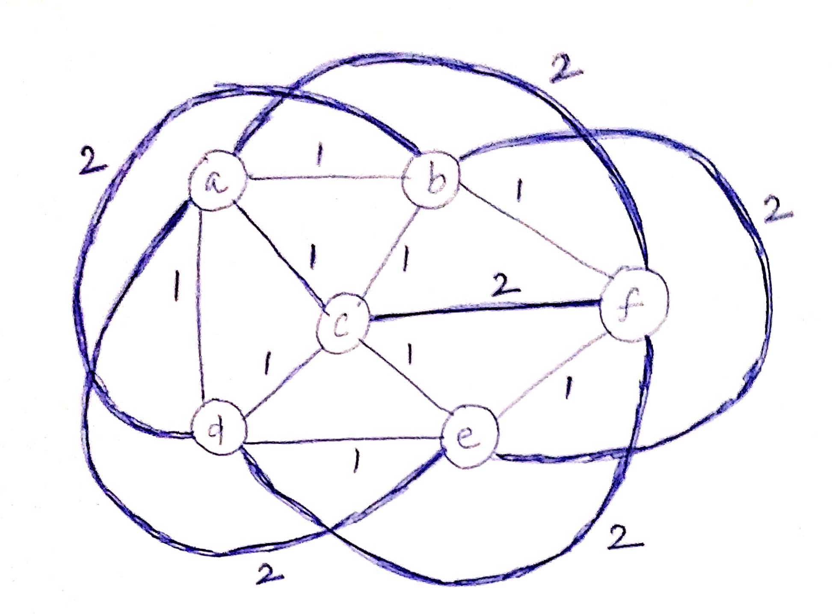

As the upper bound m on the Hamiltonian circuit length, we take m = n, where n is the number of vertices in G and G’.

Let G be a yes instance of the Hamiltonian circuit problem. Then G has a Hamiltonian circuit, and its image in G’ will have length n, making the image a yes instance of the decision traveling salesman problem.

- Hamiltonian circuit in G
a – b – f – e – c – d – a
1 1 1 1 1 1 (edge weight in G’)
G’ will have a length of 6 (ie., n=6 number of vertices in a given graph)

Conversely, if we have a Hamiltonian circuit of the length not larger than n in G’ , then its length must be exactly n and hence the circuit must be made up of edges present in G, making the inverse image of the yes instance of the decision traveling salesman problem be a yes instance of the Hamiltonian circuit problem. This completes the proof.

- For no instance,
a – b – f – d – e – c – a
1 1 2 1 1 1
- Total length 7 > n
- Such a path does not exist in G

